Sensor Controlled Greenhouse

Master Document

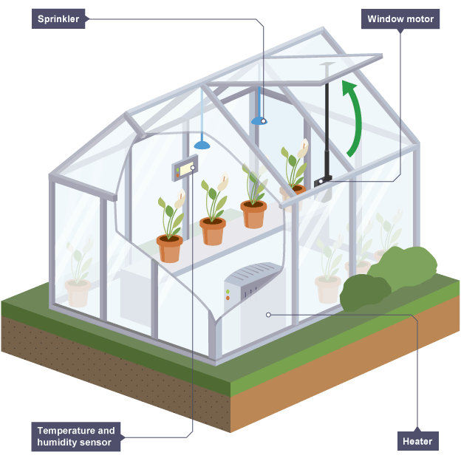

Jonathan Parkes

Andrew Radvan

Ansh Shukla

# Table of Contents

**Table of Contents** **1**

**1.0 Research and Resources** **2**

1.1 General Greenhouse 2

1.1.1 General Greenhouse Links 2

1.1.2 General Greenhouse Discussion 2

1.2 Mechanical Structure 2

1.2.1 Mechanical Structure Links 2

1.2.2 Mechanical Structure Discussion 2

**2.0 Team Organization** **2**

2.1 John 2

2.2 Ansh 2

2.3 Andrew 2

**3.0 Project Planning** **3**

3.1 Schedule 3

3.2 Cost Breakdown 3

**4.0 Overall System Design** **3**

4.1 Block Diagram of the Overall System 3

**5.0 Mechanical Systems** **3**

5.1 Greenhouse Frame 3

5.2 Soil Containers 3

5.3 Sprinkler System 3

5.4 Heater System 3

5.5 Lighting System 3

**6.0 Electrical Systems** **3**

6.1 Temperature Controller Design 3

6.2 Moisture Controller Design 3

6.3 Light Sensor Design 3

6.4 Power Delivery 4

**7.0 Software Systems** **4**

# 1.0 Research and Resources

## 1.1 General Greenhouse

### 1.1.1 General Greenhouse Links

[1] Greenhouse ideas: <http://yourhouseandgarden.com/15-cheap-easy-diy-greenhouse-projects/>

[2] Hydroponics Greenhouse Full guide: <http://www.instructables.com/id/The-Hydroponic-Automated-Networking-Climate-Con/>

[3] <https://www.planetnatural.com/greenhouse-kits/>

[4] <https://diyhacking.com/diy-build-mini-automated-greenhouse-microgreen/>

[5] <http://www.instructables.com/id/Automated-Greenhouse/>

### 1.1.2 General Greenhouse Discussion

* Make a micro-greenhouse? Something small like in [4]. This would be considerably easier on the mechanical side of things, but looks less impressive. Easier to carry around and show off though.
* [5] Seems ideal. If we do something like that, we’ll have lots of room to develop skills, but will also be on the cheaper side.
* Need to do some research into what crops to grow, since that will determine the setpoint values for our controlled parameters.

## 1.2 Mechanical Structure

### 1.2.1 Mechanical Structure Links

### 1.2.2 Mechanical Structure Discussion

## 1.2 Control Systems

### 1.2.1 Control Systems Links

[1] Sensor System: <https://www.ictlounge.com/html/control_applications_examples.htm>

[2] Paper on LEDs: <https://arxiv.org/ftp/arxiv/papers/1406/1406.3016.pdf>

### 1.2.2 Control Systems Discussion

# 2.0 Team Organization

## 2.1 John

* **Role:**
* Responsible for current tasks:

## 2.2 Ansh

* **Role:**
* Responsible for current tasks:

## 2.3 Andrew

* **Role:**
* Responsible for current tasks:

<http://www.instructables.com/id/Irrigating-your-garden-with-an-opamp-The-circuit/>

# 3.0 Project Planning

## 3.1 Schedule

## 3.2 Cost Breakdown

# 4.0 Overall System Design

## 4.1 Block Diagram of the Overall System

# 5.0 Mechanical Systems

## 5.1 Greenhouse Frame

## 5.2 Soil Containers

## 5.3 Sprinkler

## 5.4 Heater

## 5.5 Vent

## 5.6 Grow Lights

# 6.0 Electrical Systems

## 6.1 Temperature Controller Design

## 6.2 Moisture Controller Design

## 6.3 Light Sensor Design

## 6.4 Power Delivery

# 7.0 Software Systems